Lab Exercise 22 - MinIO Lifecycle Rules (Prefix, Tag, and Multi-Rule Policies)

Lab Objective
To configure and validate object lifecycle rules in MinIO using:
- Prefix-based lifecycle rules
- Tag-based lifecycle rules
- Multiple lifecycle rules in a single policy
and observe how MinIO evaluates and applies these rules.

Step 1: Configure MinIO Client Alias
mc alias set myminio http://<minio-ip>:9000 minioadmin minioadmin

Verify:
mc alias ls

Step 2: Create Bucket for Lifecycle Testing
mc mb myminio/lifecycle-lab

Step 3: Prepare Test Data Structure
Create Local Test Files
mkdir lifecycle-data
cd lifecycle-data

echo "log file" > logs-1.txt
echo "log file" > logs-2.txt
echo "report file" > reports-1.txt
echo "report file" > reports-2.txt
echo "archive file" > archive-1.txt

Upload Files Using Prefixes
mc cp logs-1.txt myminio/lifecycle-lab/logs/logs-1.txt
mc cp logs-2.txt myminio/lifecycle-lab/logs/logs-2.txt

mc cp reports-1.txt myminio/lifecycle-lab/reports/reports-1.txt
mc cp reports-2.txt myminio/lifecycle-lab/reports/reports-2.txt

mc cp archive-1.txt myminio/lifecycle-lab/archive/archive-1.txt

Verify:
mc ls --recursive myminio/lifecycle-lab

Step 4: Prefix-Based Lifecycle Rule
Objective
Expire all objects under the logs/ prefix after 1 day.

Create Prefix Lifecycle Rule File
vi prefix-rule.json

{
"Rules": [
{
"ID": "ExpireLogsAfter1Day",
"Status": "Enabled",
"Filter": {
"Prefix": "logs/"
},
"Expiration": {
"Days": 1
}
}
]
}

Apply Prefix Lifecycle Rule
mc ilm import myminio/lifecycle-lab < prefix-rule.json

Verify:
mc ilm ls myminio/lifecycle-lab

Step 5: Tag-Based Lifecycle Rule
Objective
Expire objects tagged env=dev after 2 days, regardless of prefix.

Upload Tagged Objects
mc cp reports-1.txt myminio/lifecycle-lab/dev/reports-1.txt --tags "env=dev"
mc cp archive-1.txt myminio/lifecycle-lab/dev/archive-1.txt --tags "env=dev"

Verify tags:
mc stat myminio/lifecycle-lab/dev/reports-1.txt

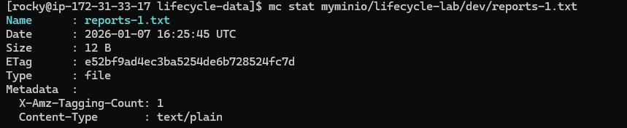
mc tag list myminio/lifecycle-lab/dev/reports-1.txt

Create Tag-Based Rule File
vi tag-rule.json

{
"Rules": [
{
"ID": "ExpireDevTaggedObjects",
"Status": "Enabled",
"Filter": {
"Tag": {
"Key": "env",
"Value": "dev"
}
},
"Expiration": {
"Days": 2
}
}
]
}

Apply Tag-Based Rule
mc ilm import myminio/lifecycle-lab < tag-rule.json

Verify:
mc ilm ls myminio/lifecycle-lab

Step 6: Multi-Rule Lifecycle Policy
Objective
Apply multiple rules simultaneously:
- Expire logs/ after 1 day
- Expire env=dev tagged objects after 2 days
- Expire archive/ after 5 days

Create Multi-Rule Policy File
vi multi-rule.json

{
"Rules": [
{
"ID": "ExpireLogs",
"Status": "Enabled",
"Filter": {
"Prefix": "logs/"
},
"Expiration": {
"Days": 1
}
},
{
"ID": "ExpireDevEnv",
"Status": "Enabled",
"Filter": {
"Tag": {
"Key": "env",
"Value": "dev"
}
},
"Expiration": {
"Days": 2
}
},
{
"ID": "ExpireArchive",
"Status": "Enabled",
"Filter": {
"Prefix": "archive/"
},
"Expiration": {
"Days": 5
}
}
]
}

Apply Multi-Rule Policy
mc ilm import myminio/lifecycle-lab < multi-rule.json

Verify:
mc ilm ls myminio/lifecycle-lab

